SAVEETHA SCHOOL OF ENGINEERING
SAVEETHA INSTITUTE OF MEDICAL AND TECHNICAL SCIENCES
INSTITUTE OF PLACEMENT AND TRAINING
CSA09 –JAVA PROGRAMMING
String

- Write a program to reverse a word using loop? (Not to use inbuilt functions)
Sample Input:
String: TEMPLE
Sample Output:
Reverse String: ELPMET
public class ReverseWord {
public static void main(String[] args) {
String input = "TEMPLE";
String reversed = reverseString(input);
System.out.println("Reverse String: " + reversed);
}

public static String reverseString(String str) {
char[] charArray = str.toCharArray();
int length = charArray.length;
char[] reversedArray = new char[length];

for (int i = 0; i < length; i++) {
reversedArray[i] = charArray[length - 1 - i];
}

return new String(reversedArray);
}
}
Output: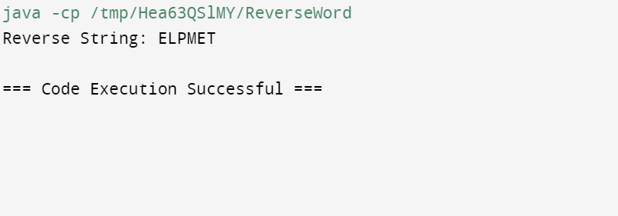

- Write a program to convent the given string to integer?
Sample Input:
String: 1234
Sample Output:
Out put String: 1234

public class StringToIntExample1{
public static void main(String args[]){
String s="200";
int i=Integer.parseInt(s);
System.out.println(i);
}}
Out put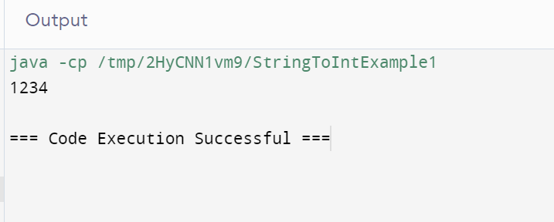
- Write a program to check the entered user name is valid or not. Get both the inputs from the user.
import java.util.Scanner;
public class UsernameValidator {
public static void main(String[] args) {
Scanner scanner = new Scanner(System.in);
System.out.println("Enter a username:");
String username = scanner.nextLine();
if (isValidUsername(username)) {
System.out.println("The username is valid.");
} else {
System.out.println("The username is invalid.");
}
scanner.close();
}
public static boolean isValidUsername(String username) {
if (username.length() < 5 || username.length() > 15) {
return false;
}

for (int i = 0; i < username.length(); i++) {
char c = username.charAt(i);
if (!Character.isLetterOrDigit(c)) {
return false;
}
}
return true;
}
}
Out put:
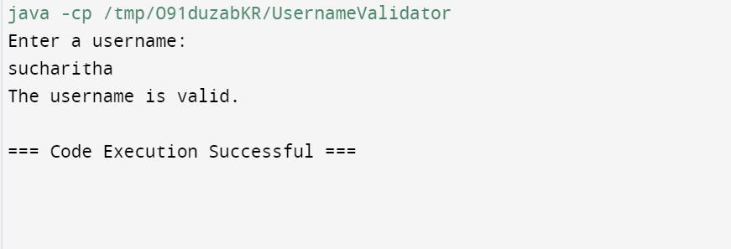
- Write a program that would sort a list of names in alphabetical order Ascending or Descending, choice get from the user?
Sample Input:
Banana
Carrot
Radish
Apple
Jack
Order(A/D) : A
Sample Output:
Apple
Banana
Carrot
Jack
Radish

import java.util.Arrays;
import java.util.Collections;
import java.util.Scanner;

public class NameSorter {
public static void main(String[] args) {
Scanner scanner = new Scanner(System.in);

System.out.println("Enter the number of names:");
int n = scanner.nextInt();
scanner.nextLine(); // Consume newline

String[] names = new String[n];
System.out.println("Enter the names:");
for (int i = 0; i < n; i++) {
names[i] = scanner.nextLine();
}

System.out.println("Order (A/D) :");
char order = scanner.next().charAt(0);

if (order == 'A' || order == 'a') {
Arrays.sort(names);
} else if (order == 'D' || order == 'd') {
Arrays.sort(names, Collections.reverseOrder());
} else {
System.out.println("Invalid order choice. Please enter 'A' for ascending or 'D' for descending.");
scanner.close();
return;
}

System.out.println("Sorted names:");
for (String name : names) {
System.out.println(name);
}

scanner.close();
}
}

Out put:

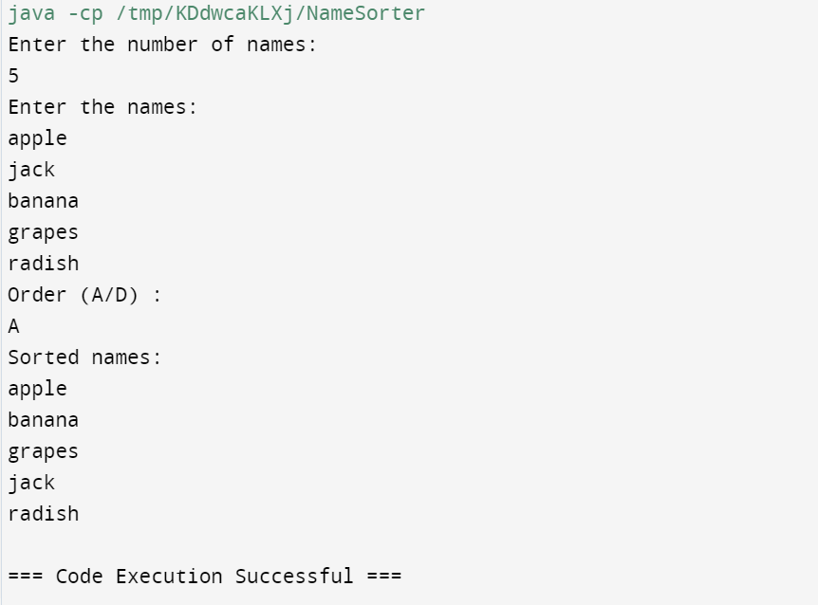
- Write a program to print the special characters separately and print number of Special characters in the line?

import java.util.Scanner;
public class SpecialCharacterCounter {
public static void main(String[] args) {
Scanner scanner = new Scanner(System.in);

System.out.println("Enter a line of text:");
String line = scanner.nextLine();
int specialCharCount = 0;
StringBuilder specialChars = new StringBuilder();
for (int i = 0; i < line.length(); i++) {
char c = line.charAt(i);
if (!Character.isLetterOrDigit(c) && !Character.isWhitespace(c)) {
specialChars.append(c).append(" ");
specialCharCount++;
}
}
System.out.println("Special characters: " + specialChars.toString().trim());
System.out.println("Number of special characters: " + specialCharCount);

scanner.close();
}
}
Out put:
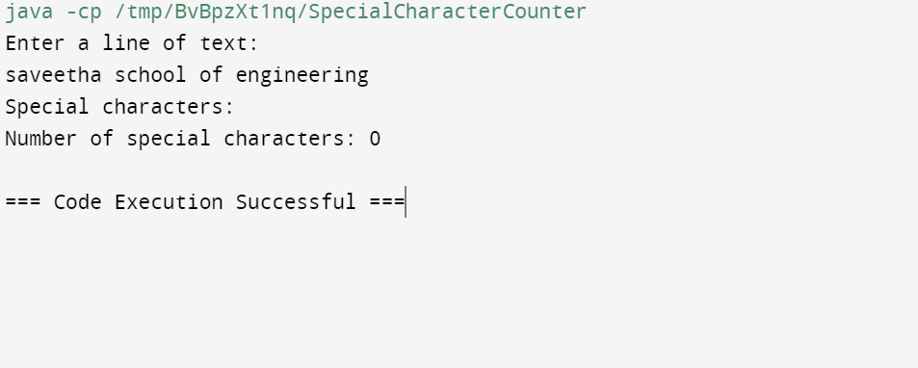
- Write a program to print the number of vowels in the given statement?
Sample Input:
Saveetha School of Engineering
Sample Output:
Number o vowels = 12

import java.util.Scanner;

public class VowelCounter {
public static void main(String[] args) {
Scanner scanner = new Scanner(System.in);

System.out.println("Enter a statement:");
String statement = scanner.nextLine();

int vowelCount = countVowels(statement);

System.out.println("Number of vowels = " + vowelCount);

scanner.close();
}

public static int countVowels(String statement) {
int count = 0;
String vowels = "AEIOUaeiou";

for (int i = 0; i < statement.length(); i++) {
char c = statement.charAt(i);
if (vowels.indexOf(c) != -1) {
count++;
}
}

return count;
}
}
Out put:

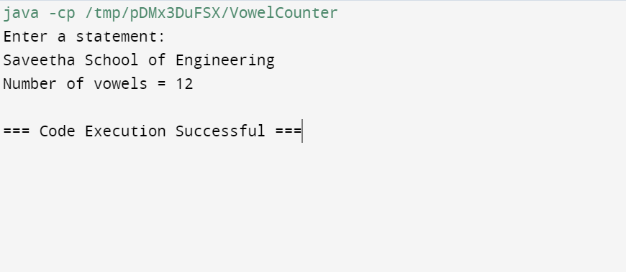
- Write a program to print consonants and vowels separately in the given word
Sample Input:
Given Word: Engineering
Sample Output:
Consonants: n g n r n g
Vowels: e i e ei
import java.util.Scanner;
public class ConsonantsAndVowels {
public static void main(String[] args) {
Scanner scanner = new Scanner(System.in);
System.out.println("Enter a word:");
String word = scanner.nextLine();
StringBuilder consonants = new StringBuilder();
StringBuilder vowels = new StringBuilder();
String vowelsList = "AEIOUaeiou";
for (int i = 0; i < word.length(); i++) {
char c = word.charAt(i);
if (Character.isLetter(c)) {
if (vowelsList.indexOf(c) != -1) {
vowels.append(c).append(" ");
} else {
consonants.append(c).append(" ");
}
}
}
System.out.println("Consonants: " + consonants.toString().trim());
System.out.println("Vowels: " + vowels.toString().trim());
scanner.close();
}
}
Out put:

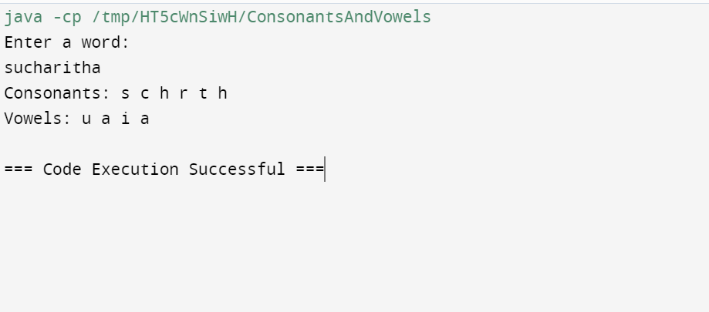
- Write a program that finds whether a given character is present in a string or not. In case it is present it prints the index at which it is present. Do not use built-in find functions to search the character.
Sample Input:
Enter the string: I am a programmer
Enter the character to be searched: p
Sample Output:
P is found in string at index: 8
Note: Check for non available Character in the given statement as Hidden Test case.
import java.util.Scanner;
public class CharacterSearch {
public static void main(String[] args) {
Scanner scanner = new Scanner(System.in);
System.out.println("Enter the string:");
String inputString = scanner.nextLine();

System.out.println("Enter the character to be searched:");
char searchChar = scanner.next().charAt(0);
int index = -1;
for (int i = 0; i < inputString.length(); i++) {
if (inputString.charAt(i) == searchChar) {
index = i;
break;
}
}
if (index != -1) {
System.out.println(searchChar + " is found in the string at index: " + index);
} else {
System.out.println(searchChar + " is not found in the string.");
}
scanner.close();
}
}
Out put:
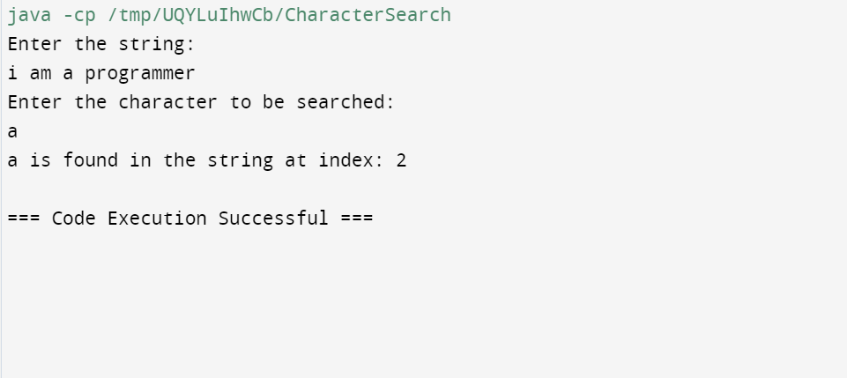

- Write a program to arrange the letters of the word alphabetically in reverse order
Sample Input:
Enter the word: MOSQUE
Sample Output:
Alphabetical Order: U S Q O M E
Test Case:
- HYPOTHECATION
- MATRICULATION
- MANIPULATION
import java.util.Arrays;
import java.util.Collections;
import java.util.Scanner;
public class ReverseAlphabeticalOrder {
public static void main(String[] args) {
Scanner scanner = new Scanner(System.in);
System.out.println("Enter the word:");
String word = scanner.nextLine();
Character[] charArray = new Character[word.length()];
for (int i = 0; i < word.length(); i++) {
charArray[i] = word.charAt(i);
}
Arrays.sort(charArray, Collections.reverseOrder());
StringBuilder sortedWord = new StringBuilder();
for (char c : charArray) {
sortedWord.append(c).append(" ");
}
System.out.println("Alphabetical Order: " + sortedWord.toString().trim());

scanner.close();
}
}
Out put:
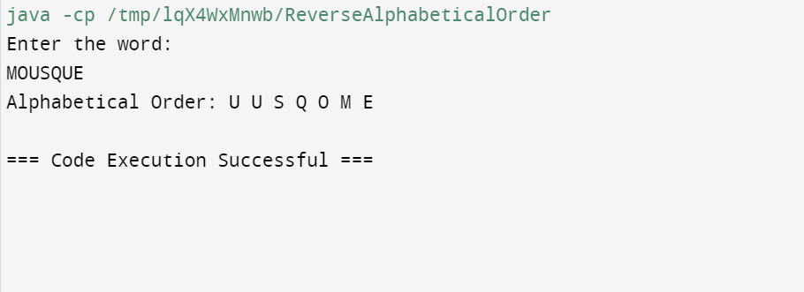
- Write a program that accepts a string from user and displays the same string after removing vowels from it.
Sample Input & Output:
Enter a string: we can play the game
The string without vowels is: w cn ply thgm
import java.util.Scanner;

public class RemoveVowels {
public static void main(String[] args) {
Scanner scanner = new Scanner(System.in);
System.out.println("Enter a string:");
String inputString = scanner.nextLine();
String stringWithoutVowels = removeVowels(inputString);
System.out.println("The string without vowels is: " + stringWithoutVowels);
scanner.close();
}
public static String removeVowels(String inputString) {
StringBuilder result = new StringBuilder();
String vowels = "AEIOUaeiou";
for (int i = 0; i < inputString.length(); i++) {
char c = inputString.charAt(i);
if (vowels.indexOf(c) == -1) {
result.append(c);
}
}
return result.toString();
}
}
Out put:
